Interpreting Data

* Group IEP students with Level ¾ math student who will support them; teacher to circulate groups with IEP students during ‘working on it’

Getting Started: (5 min)

Introduce unit: Over the next couple of lessons you will be conducting surveys, analyzing data, drawing appropriate graphs, and finding the mean, median, and mode. Today we are focusing on interpreting (understanding) a number of graphs, which will assess what you already know and what we need review and learn about graphing.

With the person beside you, answer the questions:

Why use graphs to present data?
Because they...
- are quick and direct
- highlight the most important facts
- facilitate understanding of the data
- can convince readers
- can be easily remembered
There are many different types of graphs. Name as many types of graphs as you can:
- Bar graph: displays separate data in separate columns
- double bar graph: compare 2 sets of data
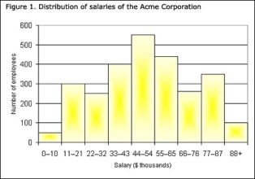
- histogram: displays continuous data (time, inches, temperature) >>
- pie chart/ circle graph: displays data as a percentage of the whole.
- Line graph: plots continuous data as points and then joins them with a line
- Scatter plot: displays the relationship between two factors of the experiment.

Why do we have different graphs? What is the purpose of each?- Question to think about throughout the lesson

Working on it (15- 20 min)
Explain activity: Groups of students will get a chart paper with questions about a graph or graphs. These questions will get you thinking about the features of a graph, interpreting data on a graph, the purpose of different graphs, and making inferences. Will get 5 minutes to discuss and answer questions regarding how they interpret data.
What is an inference? A conclusion we reach by reasoning (using what we already know and using the information we are given to come to a logical answer)- Example: If ¼ of you watch TV after school and a ¼ of you play a play station 4 game after school, I infer that at least ½ of the class has technology in their house.

Consolidation (10-15min)
As a class discuss the answers students got for the graphing questions. Resolve any misconceptions students have about pie charts, bar and line graphs.
Ask the question: Why do we have different graphs? What is the purpose of each?
Instruct students to come up with one question they can ask about a graph(s) they interpreted. Students ask their partner the question.
Remind students they will continue to work on interpreting data from graphs over the next few lessons.

